Full Stack Development with MERN
Book Store
- Introduction
• Project Title: Darshan Ease
• Team Members:1) Divya Sri Rachakonda
2)Meduri Snehitha
3)Nanganuru Hari
4)Durga Mani Sankar Majeti
5)Suresh Thota
2. Project Overview
Purpose
The Book Store Management System is a full-stack web application developed using the MERN Stack (MongoDB, Express.js, React.js, and Node.js). The primary purpose of this project is to provide an online platform where users can browse, search, and purchase books conveniently while allowing administrators to efficiently manage books, users, and customer orders.
The system is designed to simplify the traditional book purchasing process by offering a user-friendly interface, secure authentication, shopping cart functionality, online order management, and an admin dashboard. It demonstrates the implementation of modern web technologies to build a responsive and scalable e-commerce application.
Key Features
User Module
- User Registration and Login
- Secure JWT Authentication
- Browse Available Books
- Search Books by Title, Author, or Category
- View Book Details
- Add Books to Shopping Cart
- Update Cart Quantity
- Place Orders
- View Order History
- User Profile Management

Admin Module
- Admin Login
- Dashboard with Statistics
- Add New Books
- Edit Existing Books
- Delete Books
- Manage Book Inventory
- Manage Registered Users
- View and Manage Customer Orders
- Update Order Status
- Monitor Revenue and Sales
3. Architecture
3.1 Frontend Architecture (React.js)
The frontend of the Book Store Management System is developed using React.js, a component-based JavaScript library for building dynamic and responsive user interfaces. The application is organized into reusable components and pages, making the code modular, maintainable, and scalable.
React Router is used for navigation between different pages without reloading the application. Axios is used to communicate with the backend REST APIs. The frontend also uses React Hooks such as useState and useEffect for state management and lifecycle handling.
Frontend Modules
- Home Page
- User Registration
- User Login
- Book Listing
- Book Search
- Shopping Cart
- Checkout
- Order History
- Admin Dashboard
- Add/Edit/Delete Books
- Manage Users
- Manage Orders
3.2 Backend Architecture (Node.js & Express.js)
The backend is developed using Node.js and Express.js. It follows a RESTful API architecture where the frontend communicates with the server through HTTP requests.
The backend handles:
- User Authentication
- Authorization using JWT
- Book Management
- Shopping Cart Operations
- Order Processing
- User Management
- Image Upload using Multer
- Database Operations
The application follows the MVC (Model-View-Controller) architecture.
3.3 Database Architecture (MongoDB)
The application uses MongoDB, a NoSQL document-oriented database, to store application data. Mongoose is used as an Object Data Modeling (ODM) library to define schemas and interact with MongoDB.
Each collection stores related documents.
Database Collections
User Collection
Stores registered users.
Field | Type
_id | ObjectId
name | String
email | String
password | String (Encrypted)
role | String (User/Admin)

Book Collection
Stores all available books.
Field | Type
_id | ObjectId
title | String
author | String
category | String
description | String
price | Number
stock | Number
image | String

Cart Collection
Stores user shopping cart items.
Field | Type
_id | ObjectId
user | ObjectId
book | ObjectId
quantity | Number

Order Collection
Stores customer orders.
Field | Type
_id | ObjectId
user | ObjectId
items | Array
total | Number
status | String
createdAt | Date
4. Setup Instructions
4.1 Prerequisites
Before setting up the Book Store Management System, ensure that the following software and tools are installed on your computer.
Software Requirements
Software | Version
Node.js | v18 or above
npm (Node Package Manager) | Latest
MongoDB Community Server or MongoDB Atlas | Latest
Visual Studio Code | Latest
Git | Latest
GitHub Account | Required for deployment
Postman | API Testing
Google Chrome / Microsoft Edge | Latest
4.2 Installation
Step 1: Clone the Repository
Clone the project from GitHub using the following command:
git clone https://github.com/yourusername/BookStore.git
Move into the project directory.
cd BookStore

Step 2: Install Backend Dependencies
Navigate to the server folder.
cd server
Install all required packages.
npm install
This installs dependencies such as:
- Express.js
- Mongoose
- JWT
- BCrypt
- Multer
- Dotenv
- CORS
- Nodemon

Step 3: Install Frontend Dependencies
Open another terminal.
Navigate to the client folder.
cd client
Install all frontend packages.
npm install
This installs:
- React.js
- React Router DOM
- Axios
- Bootstrap
- Vite
5. Folder Structure:-
BookStore/
│
├── client/
│ ├── public/
│ ├── src/
│ │ ├── components/
│ │ ├── context/
│ │ ├── pages/
│ │ ├── services/
│ │ ├── App.jsx
│ │ └── main.jsx
│ └── package.json
│
├── server/
│ ├── config/
│ ├── controllers/
│ ├── middleware/
│ ├── models/
│ ├── routes/
│ ├── uploads/
│ ├── .env
│ ├── package.json
│ └── server.js
│
├── README.md
└── .gitignore
6. Running the Application
After successfully installing all dependencies and configuring the environment variables, the application can be executed by starting both the backend and frontend servers.

6.1 Start the Backend Server
Step 1: Open Terminal
Navigate to the server directory.
cd BookStore/server
Step 2: Install Dependencies (First Time Only)
npm install
Step 3: Start the Backend Server
For development (using Nodemon):
npm run dev
npm start
7. API Documentation
The Book Store Management System uses REST APIs to allow communication between the React frontend and the Node.js backend. These APIs handle user authentication, book management, cart operations, orders, and admin functions.
API Summary
Module | Method | Endpoint | Purpose
Authentication | POST | /api/auth/register | Register a new user
Authentication | POST | /api/auth/login | User login
Books | GET | /api/books | View all books
Books | POST | /api/books | Add a new book
Books | PUT | /api/books/:id | Update a book
Books | DELETE | /api/books/:id | Delete a book
Cart | GET | /api/cart | View cart
Cart | POST | /api/cart | Add book to cart
Orders | POST | /api/orders | Place order
Orders | GET | /api/orders | View orders
Wishlist | POST | /api/wishlist | Add to wishlist
Admin | GET | /api/admin/dashboard | View dashboard
Admin | GET | /api/admin/users | Manage users
Admin | GET | /api/admin/orders | Manage orders
8. Authentication
The Book Store Management System uses JSON Web Token (JWT) based authentication to provide secure access to the application. Authentication verifies the identity of users, while authorization controls what actions a user is allowed to perform.

8.1 User Authentication
Users must register with their name, email, and password before accessing the application. During registration, the password is encrypted using BCrypt and stored securely in the MongoDB database.
When a user logs in with a valid email and password, the server verifies the credentials. If authentication is successful, the server generates a JWT (JSON Web Token) and sends it to the client.
The token is stored in the browser's localStorage and is included in future API requests to access protected resources.

8.2 Authorization
The application supports Role-Based Authorization, where users are assigned one of the following roles:
- User: Can browse books, add books to the cart, place orders, and view order history.
- Admin: Has all user permissions and can also manage books, users, and customer orders through the Admin Dashboard.
Before executing protected operations, the server checks the user's role to ensure they have permission to perform the requested action.
9. User Interface :-
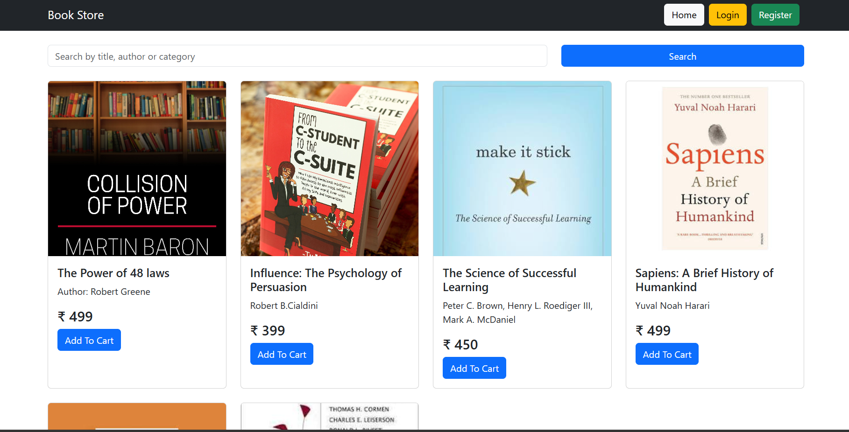
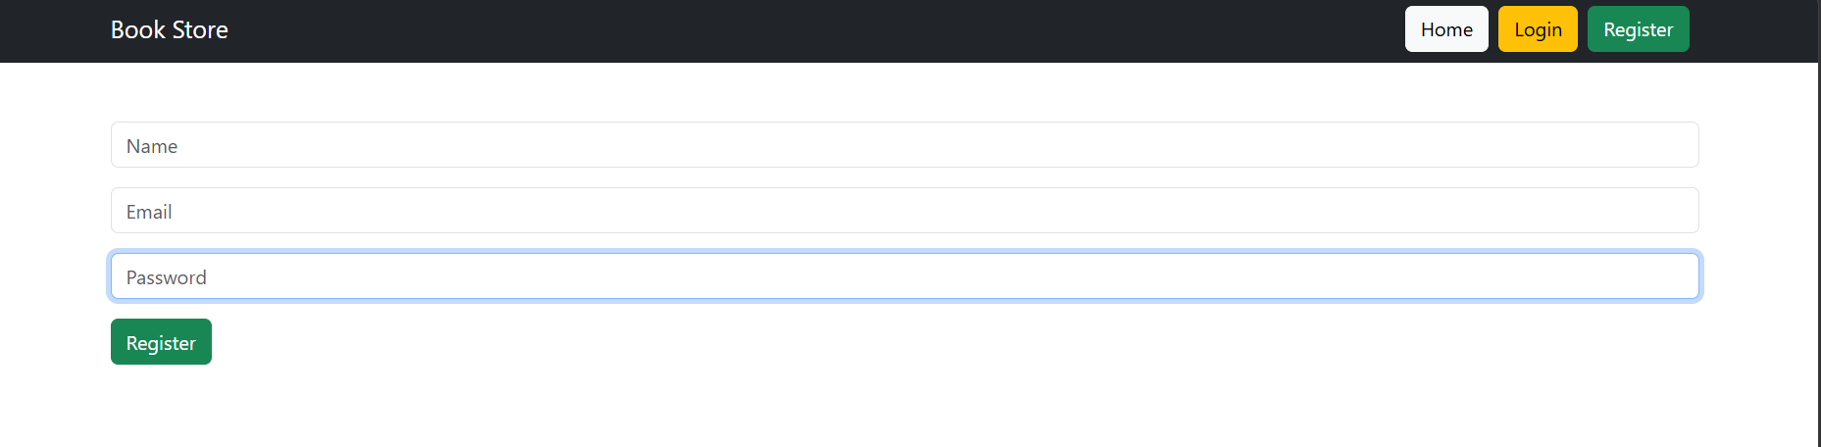
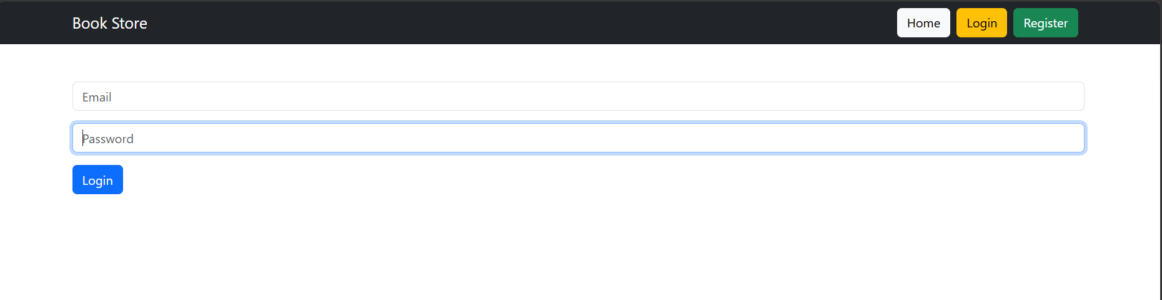
10. Testing
Testing is an important phase in software development that ensures the application works correctly and meets user requirements. The Book Store Management System was tested by checking each module individually and verifying that all features functioned as expected.

10.1 Testing Strategy
The application was tested using manual testing. Each feature was tested independently to ensure correct functionality before integrating it with the complete system.
The following modules were tested:
- User Registration
- User Login
- Book Management
- Search Functionality
- Shopping Cart
- Order Placement
- Admin Dashboard
- User Management
- Order Management

10.2 Testing Tools
The following tools were used during testing:
Tool | Purpose
Google Chrome | Testing the user interface
Postman | Testing REST API endpoints
MongoDB Compass | Verifying database records
Visual Studio Code | Debugging application code
Browser Developer Tools | Checking console errors and network requests

11. Screenshots or Demo


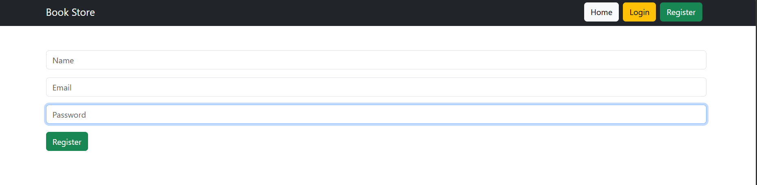
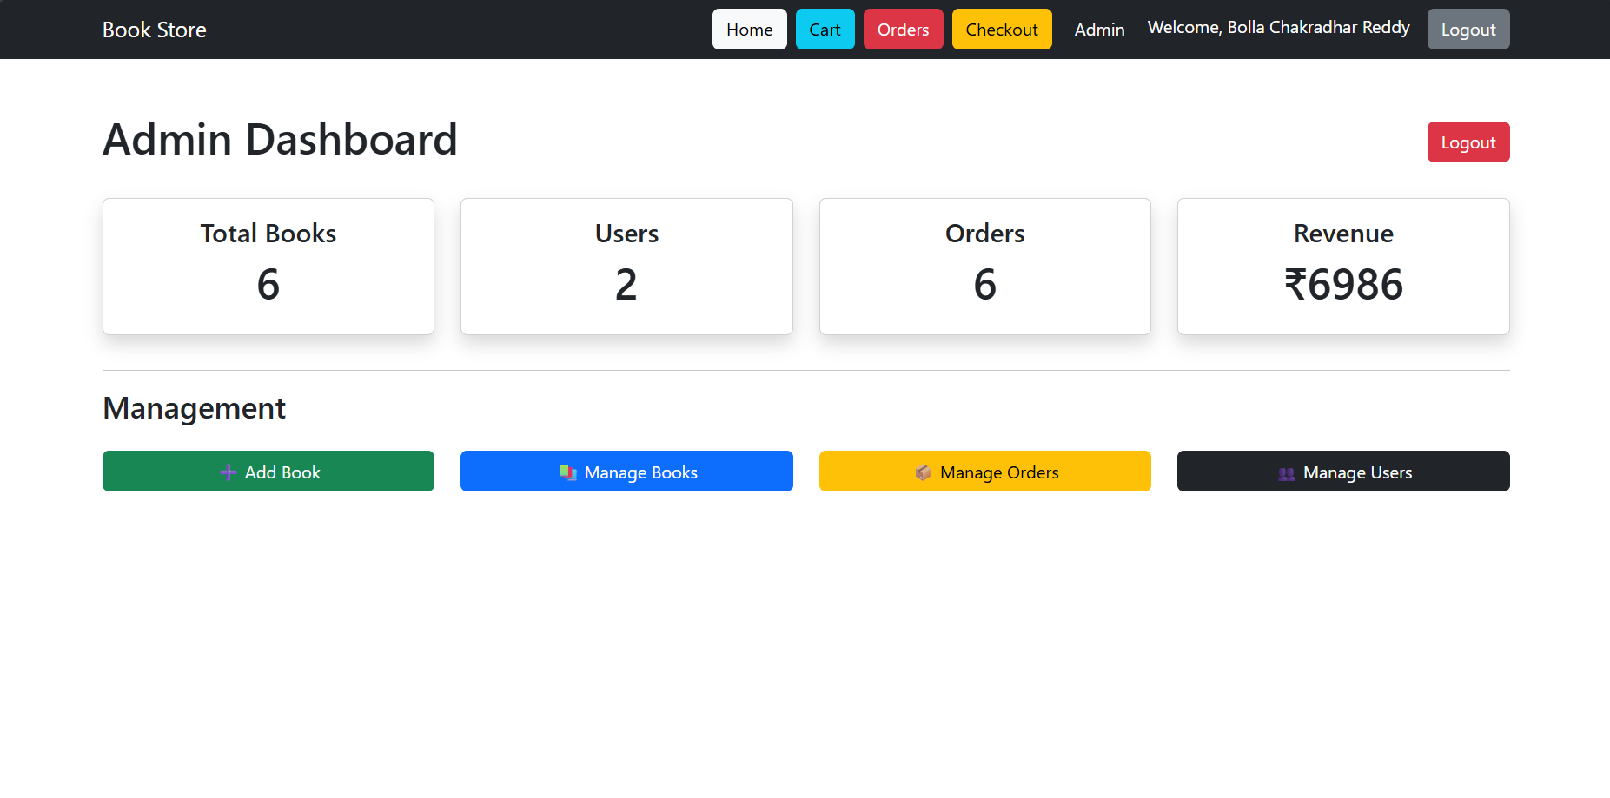
Although the Book Store Management System is fully functional, there are a few limitations and known issues that can be improved in future versions.
- The application does not currently send email notifications for user registration or order confirmation.
- Payment functionality may require additional configuration (such as Razorpay credentials) before it can be used in a production environment.
- The search feature currently supports searching by title, author, and category only. Advanced filters such as price range, ratings, and publication year are not available.
- The project relies on an active internet connection and a running backend server to function correctly.
- Some error messages are basic and can be improved to provide more user-friendly feedback.
- User profile management features such as updating personal information or changing passwords are not yet implemented.

13. Future Enhancements
The Book Store Management System can be enhanced by adding several new features to improve functionality, security, and user experience.
- Integrate secure online payment gateways such as Razorpay, Stripe, or PayPal.
- Add book ratings and customer reviews.
- Implement personalized book recommendations based on user preferences and purchase history.
- Add advanced search and filtering options, including price range, author, category, and ratings.
- Enable users to manage their profiles, change passwords, and update personal information.
- Send email notifications for registration, order confirmation, and password reset.
- Integrate cloud storage services such as Cloudinary or AWS S3 for reliable image storage.
- Develop a mobile application using React Native for Android and iOS devices.
- Add sales reports and graphical analytics to the admin dashboard.
- Implement inventory alerts to notify administrators when book stock is low.
- Add coupon codes, discounts, and promotional offers.
- Introduce multilingual support to make the application accessible to users in different languages.
- Deploy the application using cloud platforms such as Render, Vercel, and MongoDB Atlas for better scalability and availability.

